Home work

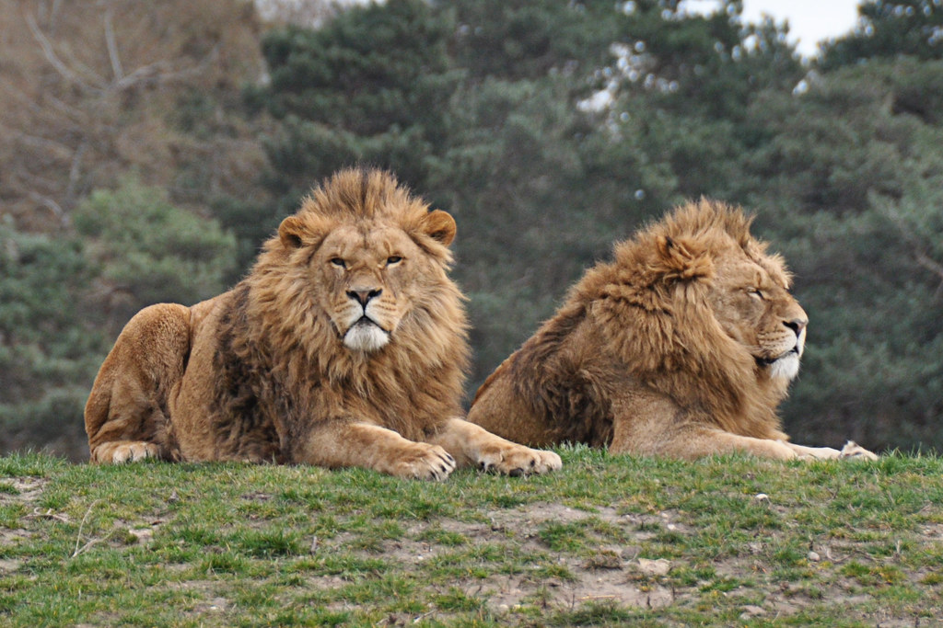

This is one of my favorite photos. It depicts 2 lions. I took this photo in 2020, when I traveled with my family to the Lions Park in Crimea.

This park is very famous among the residents of Crimea. It is very beautiful and has many different types of animals. I keep this photo on my computer in a folder where I keep beautiful photos from other places. I really like this photo for many reasons. The first is that I think lions are very beautiful animals. The second is their posture. They lie very nicely. I took this photo with my dad because my mom and sister were afraid to get so close to the lions.

I love this photo because this is my first beautiful photo of such beautiful animals. For a very long time this photograph stood on my desktop.